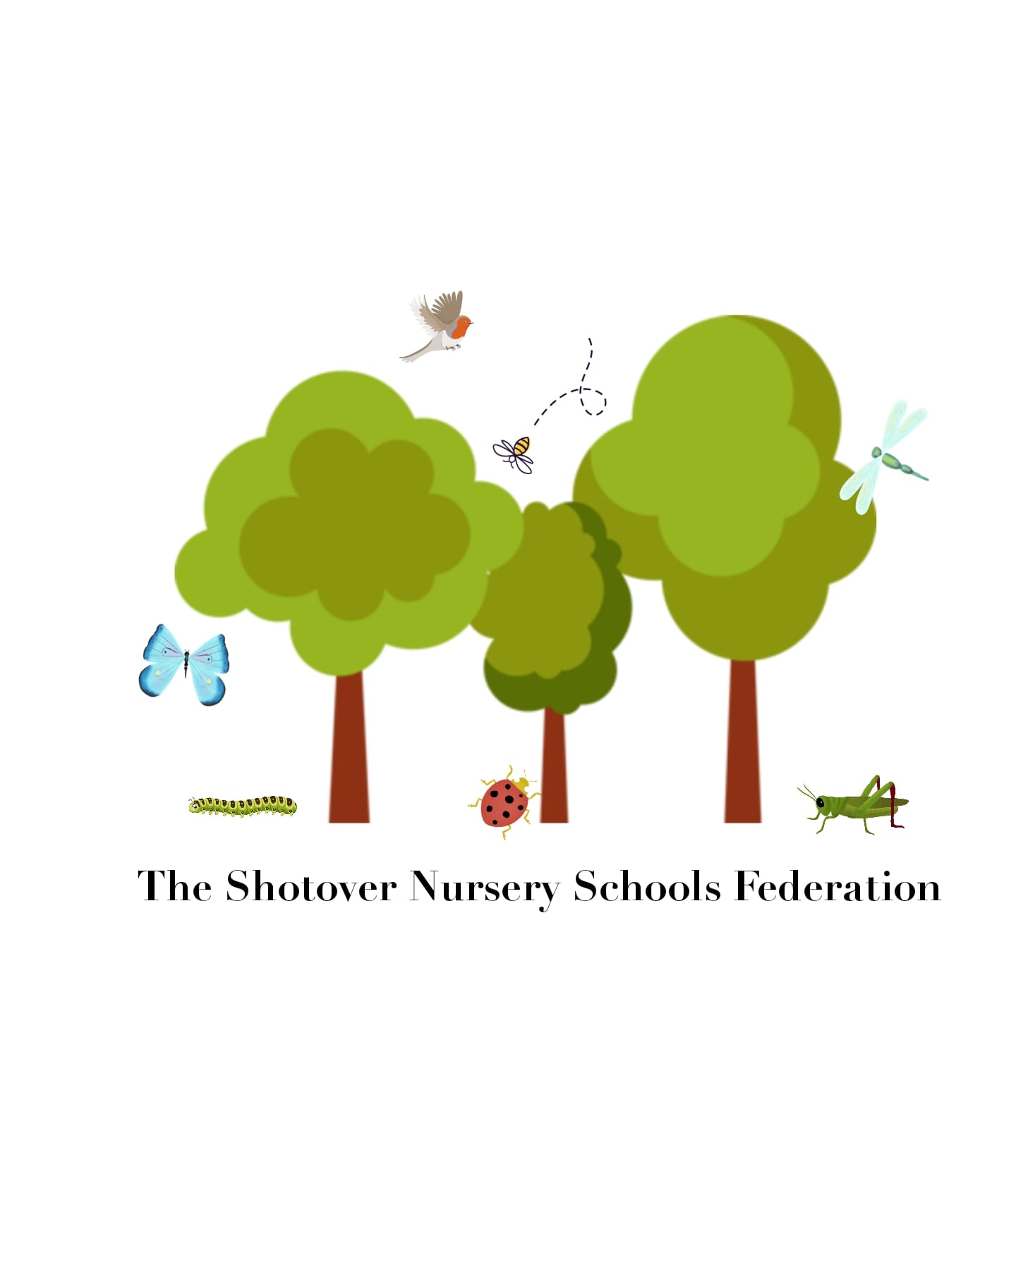

Written Statement of Behaviour Principles
At the Shotover Nursery School Federation we believe every child matters and strive to provide rich experiences that support each child’s unique development based on early childhood principles. The school aims to create a positive atmosphere based on shared values, where children and their families, staff, governors and volunteers feel valued and work together to achieve good relationships and high standards of behaviour.
Our behaviour principles are:
• Children have the right to feel safe and need to feel safe and secure in order to learn and develop.
• Children have the right to be respected; adults observe and listen to children and respect what they are trying to communicate.
• All behaviour is a form of communication – children show us how they feel through their behaviour.
• Staff are supported in helping to understand what children communicate through their behaviour.
• Staff are positive role models to help children learn expected behaviour and through strong supportive relationships help children develop self control.
• We use consistent strategies to help children develop social and emotional engagement and regulate their responses, focusing on the behaviour and not the child.
• We involve families in any behaviour incidents and share the rationale of our boundaries and expectations so that parents can support their child as necessary.
• Sanctions, including exclusion, are used very rarely and as a last resort.
This written statement of behaviour principles is reviewed and approved by the federated governing body annually.
1

