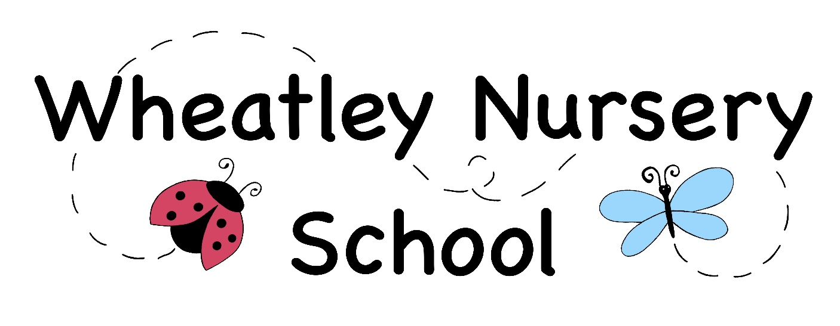

Behaviour Policy

Signed by
Chair of Governors: Lynn Wong

Date: 26/03/24

This policy will be reviewed as per the review schedule set by the Governing body

Wheatley Nursery School
Behaviour Policy

Aims
At Wheatley Nursery School we believe every child matters and strive to provide rich experiences that support each child’s unique development based on early childhood principles. The school aims to create a positive atmosphere based on shared values, where children and their families, staff, governors, and volunteers feel valued and work together to achieve good relationships and high standards of behaviour.
Our behaviour principles are:
- Children have the right to feel safe and need to feel safe and secure to learn and develop.
- Children have the right to be respected; adults observe and listen to children and respect what they are trying to communicate.
- All behaviour is a form of communication – children show us how they feel through their behaviour.
- Staff are supported in helping to understand what children communicate through their behaviour.
- Staff are positive role models to help children learn expected behaviour and through strong supportive relationships help children develop self-control.
- We use consistent strategies to help children develop social and emotional engagement and regulate their responses, focusing on the behaviour and not the child.
- We involve families in any behaviour incidents and share the rationale of our boundaries and expectations so that parents can support their child as necessary.
- Sanctions, including exclusion, are used very rarely and as a last resort.

This written statement of behaviour principles is reviewed and approved by the federated governing body annually.

“Underpinning children’s personal development are the important attachments that shape their social world. Strong, warm, and supportive relationships with adults enable children to learn how to understand their own feelings and those of others.” (EYFS Statutory Framework 2023)

Our School Rules

- We are kind to everyone.
- We listen to others.
- We share and take turns.
- We take care of the things around us.

School responsibilities

All staff are responsible for the modelling of good behaviour through managing their own emotional wellbeing, promoting and establishing positive relationships and dealing with incidents around school in a way that is fair to all pupils regardless of age, ability, gender, race or faith.

The Headteacher is responsible for the overall management of behaviour, the monitoring of this policy and guidance, for the consistent application of the procedures, ensuring that staff understand and carry out their responsibilities and for providing appropriate staff training.

The Headteacher will also be involved in the management of serious incidents with children and parents. The Headteacher reports headline data for behaviour and exclusions to the Governing Body in line with the annual reporting schedule. Governors will review the behaviour and exclusion data in line with the annual reporting schedule.

The governors are responsible for reviewing the behaviour principles, agreeing the policy and monitoring any significant behaviour concerns/trends including suspensions and exclusions.

Teachers and Early Years support workers are responsible for supporting, managing, and monitoring the behaviour of all children in their key groups and for following the agreed procedures in all areas of school and off site. They are also responsible for communicating with parents/ carers regarding both positive and negative behaviours, creating STARR charts and recording incidents on communication logs or the physical intervention spreadsheet as appropriate.

Teaching Assistants are responsible for following the procedures under the guidance of the key people, Headteacher and for recording incidents using the agreed systems.

Procedures

In order to manage children’s behaviour in an appropriate way we will:
- attend relevant training to help understand and guide appropriate models of behaviour
- implement the setting’s behaviour procedures including the stepped approach
- have the necessary skills to support other staff with behaviour issues and to access expert advice, if necessary
- follow a stepped approach to managing behaviour.

Stepped approach
Step 1
We will ensure that EYFS and related guidance for ‘behaviour management’ is reviewed regularly and incorporated into relevant policy and procedures. All staff will receive training and support to address issues relating to behaviour including applying initial and focused intervention approaches (see below) and modelling strategies for self-regulation.

Step 2
We address unwanted behaviours using agreed and consistently applied initial intervention approaches. If the unwanted behaviour does not reoccur or cause concern, then normal monitoring will resume.

Behaviours that result in concern for the child and/or others will be discussed between the key person and SENCO/Headteacher. During the meeting, the key person will use their knowledge and assessments of the child to share any known influencing factors (new baby, additional needs, illness etc.) to place the behaviour into context. Appropriate adjustments to practice will be agreed and, if successful, normal monitoring will resume.

If the behaviour continues to reoccur and remains a concern, then the key person and SENCO/Headteacher should liaise with parents to discuss possible reasons for the behaviour and to agree next steps. If relevant and appropriate, the views of the child relating to their behaviour should be sought and considered to help identify a cause. If a cause for the behaviour is not known or only occurs whilst in the school, then the SENCO/Headteacher will suggest using a focused intervention approach to identify a trigger for the behaviour.

If a trigger is identified, then the SENCO /Headteacher and key person will meet with the parents to plan support for the child through developing focused interventions in an action plan. If relevant, recommended actions for dealing with the behaviour at home should be agreed with the parent/s and incorporated into the plan. Other members of the staff team should be informed of the agreed actions in the action plan and help implement the actions. The plan should be monitored and reviewed regularly by the key person and SENCO/Headteacher until improvement is noticed.

All incidents and intervention relating to unwanted and challenging behaviour by children should be clearly and appropriately logged (see below section on recording and monitoring).

Step 3
If, despite applying the initial intervention and focused intervention approaches, the behaviour continues to occur and/or is of significant concern, then the key person and SENCO/Headteacher will invite the parents to a meeting to discuss external referral and next steps for supporting the child in the school.

Possible outcomes may be to commence the Early Help process and seek specialist help for the child – this support may address either developmental or welfare needs. If necessary, it may also be agreed that the child should be referred for an Education, Health and Care assessment. If the child’s behaviour is part of a range of welfare concerns that also include a concern that the child may be suffering or likely to suffer significant harm staff should refer to the DSL and follow the Safeguarding and Children and Child Procedures.

Any advice provided by external agencies should be incorporated into the child’s action plan and the lead person should make sure regular multi-disciplinary meetings are held to review the child’s progress.

The curriculum and the learning environment

We teach self-regulation skills through modelling, suggesting strategies, providing frequent opportunities to practice, and scaffolding to support children to use self-regulation skills. We incorporate choices in routines so that children are active agents in their own learning. The foundations of emotional and cognitive self-regulation in the early years are integrally tied together, and both are necessary for behavioural self-regulation. Emotions running very high get in the way of cognitive aspects of self-regulation, as a child who is experiencing very strong emotions will have difficulty in holding back impulses, focusing attention, or thinking in flexible ways to solve problems.

Self-regulation involves children’s developing ability to regulate their emotions, thoughts and behaviour to enable them to act in positive ways toward a goal. Self-regulation grows out of co-regulation, where adults and children work together toward a common purpose, including finding ways to resolve upsets from stress in any domain and return to balance. The foundations of emotional and cognitive self-regulation in the early years are integrally tied together, and both are necessary for behavioural self-regulation.
Managing unacceptable behaviour
All behaviour is a form of communication. We feel it is important to remember that a child who has “lost control” (disruption, throwing, swearing etc.) is demonstrating that they are not ok. They may be scared, hurt, confused, angry, anxious etc. It is important to confirm their feelings and let them know that it is our job to help. As already detailed, this is to be achieved through positive interactions between child and adult.

Sharing concerns with parents
When there are ongoing concerns about a child’s behaviour, we share these at a team meeting. Part of that discussion is how to work in partnership with the parents and share information and discuss strategies that will support the child.
If a child has been marked at nursery, this will be shared with the parent through the accident form.
If the injury was caused intentionally, the child’s key person will take the other parent to one side and inform them objectively and in confidence about the incident. They will reassure the parents that the incident was fully dealt with at nursery.
Further choices to support regulating behaviour.

Young children find it difficult to express themselves, will often find it difficult to share and will become upset. This is normal behaviour for most children at two years old or younger. This may mean a short spell away from other children and activities in the company of one adult. The child may need their key person to:
- Distract them or by encouraging them to take part in another activity.
- Give them an opportunity to spend time in a quieter space. This helps children to regulate their behaviour by being in a calming atmosphere which does not offer too many stimuli.

The child needs to know:
- That such behaviour will always be stopped
- The reasons why it is not acceptable to behave that way
- That the child is still wanted and valued
- That adult help will be available to help the child avoid such behaviour in the future
- That if the unacceptable behaviour arose from strong feelings of anger or frustration, there is nothing wrong with the feelings themselves, only the way in which they were expressed.

The use of rewards

We use praise to encourage children to try new challenges and to communicate those attitudes that we would like to see in their social and learning skills. We are conscious as a staff group that each time we praise something, we reinforce the message: ‘What we pay attention to is what we get more of’. We give praise for the strategies that the child uses to approach a learning activity e.g. ‘well done for trying your best to ... This type of praise encourages children to try hard and build upon their learning skills. Staff are also aware of the need to reflect on unconscious bias, and this informs the way they manage behaviour. (We encourage staff to avoid gender stereotyping and discourage staff from saying ‘Good Boy! or ‘Good Girl!’)

We understand that it is important to have an overall view of the bigger picture with regards to behaviour in the school, and that identifying children who are consistently making excellent behaviour and choices, as well as those who are finding it difficult to self-regulate is important.

We believe precision feedback is effective when it is both deserved and informative. Attention is likely to be held through activities that are intrinsically motivating. Extrinsic rewards are used sparingly to encourage a learner to stay on task, as we recognise such rewards typically have limited impact once withdrawn.

Developing emotional literacy

We use a range of strategies to support children in understanding their boundaries, how to manage their feelings and how to put things right when they have gone wrong. This includes forced alternatives. We use a range of de-escalation strategies such as distraction to diffuse conflict.

Emotional coaching:
Staff respond fully to children’s expressions of their feelings and help them to learn to regulate them for themselves- not just to make them feel better but as a crucial part of building their emotional resilience and assisting their development into fulfilled and balanced adults: Emotional coaching focuses on building a child’s self-regulation of their behaviour ( internal regulation), rather than relying on external frameworks ( sanctions and rewards) to regulate a child’s behaviour.
Our responses provide a consistent approach to managing children’s unwanted behaviour. Staff are mindful of ‘triggers’ for children e.g. transition times. Where necessary, we support children with coping strategies at these times e.g. giving advanced warning of the end of an activity using Now/Next visuals and the use of visual timetables.
Where children display persistent unwanted behaviours, these strategies may be ineffective. In such cases we would talk to parents and involve them in a plan. We carefully evaluate the curriculum, classroom organization and management to eliminate any of these as contributory factors. Additional specialists help and advice may be necessary, and we develop an individual positive handling plan
Before intervening in any conflict, consider what you know about the children involved (the stresses in their lives, level of understanding, needs etc.). If the behaviour is dangerous, intervene immediately. If not, decide whether to observe to see if a solution can be found. Managing any situation should always start with the procedures below. If the behaviour becomes unmanageable or dangerous to the child or others, ask a colleague for support and implement the strategies listed here. Children should not be brought out of the class unless the child’s behaviour is dangerous or inappropriate to other children within the nursery.
Responses may involve:
- Stopping the play and acknowledging the child or children’s feelings-e.g. ‘I can see you are angry...’ ‘I wonder if you are feeling worried……’
- Referring directly to the Golden Choices ‘...but do you remember we ask you to be kind and friendly?
- Comforting the child who has been hurt first but also acknowledging that the child who has hurt someone might also be hurt and upset. You might say ‘I understand you are all upset. We can talk together to try to make it better. Remember, you do not know what happened before, all behaviour is communication
- Ensuring each child has a turn to speak - Do not ask, “Why did you…?” Use TED Simply ask “Tell me what happened…’ ‘Can you explain what happened……Can you describe what happened…
- Talking through the situation with the children (try to get them to see the other’s point of view. If this is not possible then model the appropriate behaviour. “You did…………., I feel…………., I want……………. I wonder if that made X feel……. (E.g. “You scratched me, I feel hurt, I want a turn…
- Re-stating / reframing the problem – focusing on the problem rather than the behaviour and remaining objective and non-judgmental.
- Where possible, encouraging children to think how they can repair the situation/make things better e.g. bathe a wound, fetch a tissue, mend a book, clear up some toys. Give them time for this and offer support with it. Ask both children – to the hurt child ‘what would make the situation better for you? to the child that hurt ‘What could you do or say that might make X feel better?’
- Do not get stuck in demands. Do not demand that the child says sorry to the hurt child. Remember even adults find it difficult to say sorry. It is a complex concept. Encourage the child to think about how they could show they are sorry through their actions e.g. ‘I think if we got X a tissue for her bump, she would feel much better and know that we feel sorry for hurting her.’
Calming down

If a child needs an opportunity to calm down, they may be supported to sit down or given space until they are calm enough to resolve a situation. By helping the child to return to a normal state, we are helping the brain to develop the physiological response system that will help the child be able to manage their own feelings. We do not punish a child's rage, as that will have the opposite effect. Some children may choose to come to an adult for a cuddle when upset. Other children may prefer a quiet space and to be given time to calm with some favourite items/toys, whilst knowing an adult is nearby and available to them.

Once calm we offer children explanations and discuss the incident with them to their level of understanding. We respect children’s verbal and non-verbal communication regarding their preference for a cuddle or touch.

Once calm the child should be given the opportunity to explain their viewpoint and to suggest ways to resolve difficult situations. If behaviour has been inappropriate, a child will be expected to show remorse and make reparations as appropriate. Making reparations may include a child apologising, however it is not helpful to simply say to a child; ‘say sorry’. This can then become something said without meaning. We encourage children to think of ways in which they can make what has happened better. For example, they may choose to give their friend a cuddle and say sorry if they have had a disagreement, or they may take them their favourite toy or make them a picture. The important thing is that the amends that they choose to make have meaning. We suggest ideas to children where they need support.

Staff development and support

During staff meetings staff can discuss behaviour strategies and make contributions to behaviour risk assessments/positive handling plans, if required. Known risks are highlighted to ensure that staff use a uniform approach.

Anti-bullying
Children have the right to play in a safe and supportive environment.
It is the intention of Wheatley Nursery School to help the child and the parents/carers to develop a good understanding of what is developmentally appropriate in a situation. This is to prevent any action being hurtful, repetitive, or becoming a power imbalance which could escalate. The behaviour policy is written to help us all to live in an anti-bullying community.
Children will not be called ‘bullies’ at Wheatley Nursery School. This is an unhelpful label and says that bullying is something you are rather than a behaviour choice you can change. The behaviour will be referred to as the action/or actions taken and related to the effect it has on the other child. It is important that children are not told to fight back as this will make matters worse. We will work with parents to ensure they understand our approach to relationships in nursery.

At Wheatley Nursery School we:
- raise awareness of the issue of bullying in the school and ensure that the school policy on bullying is made known to all school staff, pupils, parents, and governors.
- ensure that all incidents of bullying are dealt with fairly and consistently by all staff, ensuring that all school staff have the opportunity to receive training, guidance and advice on appropriate methods for dealing with incidents of bullying, including online through the use of the internet and devices.
- ensure an ethos in school where pupils feel safe and confident that if they tell an adult about an incident, it will be dealt with and not ignored or thought of as telling tales.
- keep parents/carers informed of incidents of bullying and how they have been dealt with and ensure staff complete incident records and where appropriate incident sheets, to monitor, inform others and record issues of bullying.

Response to extreme incidents/ suspensions

At Wheatley Nursery School we believe that all children have the right to early years’ education and as such a reduced offer will only be considered as a last resort or when the safety of the other children and adults in the school is threatened. When serious incidents occur or persistent disruptive behaviour is evident, time away from the nursery room to reset may be necessary.

Extreme physical behaviour and aggression or persistent disruptive and challenging behaviour may very occasionally lead to external pupil suspension. Only the headteacher has the power to suspend a child from school for one or more fixed periods, for up to 45 days in any one school year. The headteacher may also exclude a pupil permanently. It is also possible for the headteacher to convert a fixed-term suspension into a permanent exclusion if the circumstances are extreme and warrant this.

Equality

The school expects all members of the school community to adhere to this policy consistently, fairly and without prejudice and with regard to the Equality Act 2010.

We may make reasonable adjustments for pupils. These will be recorded on an individual SEN positive handling plan outlining the provision needed for a particular individual. This may include the development of behaviour support strategies with the advice of external agencies e.g. Educational Psychologist, behaviour consultant.
• If appropriate, we may put in place a reduced offer in line with the county guidelines for pupils missing out (http://schools.oxfordshire.gov.uk/cms/content/pupils-missing-out).
- We may carry out a risk assessment based on prior behaviours where appropriate.

Physical Intervention

Physical intervention or the use of ‘reasonable force’ is only ever used to prevent a pupil committing an offence, injuring themselves or others or damaging property or in order to maintain the good order in our school. All staff are trained in de-escalation strategies to avoid the use of physical restraint or intervention. If physical intervention is used, it is recorded on the physical intervention spreadsheet.

Recording and Monitoring

Key persons are responsible for recording any incidents of unwanted behaviours on the record STARR charts. They will work with parents to develop a positive relationship plan where necessary, recording the preventative strategies and positive behaviours we would like to see. The STARR chart is used to unpick what the behaviours are telling us.

We use a record of communication log where there are safeguarding concerns or when we work with outside agencies on supporting a child’s behaviour.

Physical interventions are recorded on a physical intervention spreadsheet.

Records are monitored by the SENCO/Headteacher to ensure consistency in recording and to see if any patterns of unwanted behaviour occur.

Rough and tumble play and fantasy aggression

Young children often engage in play that has aggressive themes - such as superhero and weapon play. Some children appear preoccupied with these themes, but their behaviour is not necessarily a precursor to hurtful behaviour or bullying, although it may be inconsiderate at times and may need addressing using strategies as above. We recognise that teasing and rough and tumble play are normal for young children and are acceptable within limits. We do not consider this play to be aggressive. We will develop strategies to contain play that are agreed with the children, and understood by them, with acceptable behavioural boundaries to ensure children are not hurt. We recognise that fantasy play also contains many violent dramatic strategies - blowing up, shooting etc., and that themes often refer to 'goodies and baddies'. These offer opportunities for us to explore concepts of right and wrong. Staff will tune in to the content of the play and may suggest alternative strategies for heroes and heroines, making the most of 'teachable moments' to encourage empathy and lateral thinking to explore alternative scenarios and strategies for conflict resolution.

Respectful relationships and names

To support the development of respectful relationships at Wheatley Nursery School, staff will use the name chosen by parents/carers for their own child.
The reasons for this are:
● To help children develop their identity.
● To avoid confusion for the child and family
● To show respect
● To keep children safe and help children develop their identity.

Children who are young need to know and expect people to call them by their own name. The youngest of children are still learning to respond to their own name. Using the child’s given name will help children to identify with their name and to give them time to develop their own character and identify which is unique to them. It is a right of a child to be known by their given name.

We avoid giving or using nicknames. If a parent adds a shortened form of their child’s name to the registration details or lets us know that they would like us to call their child by a shortened version of their name, then we can use that name to refer to the child.

Nicknames are to be avoided because they can cause confusion for the child. Research has shown that nicknames can come to stand for how we see ourselves. Some nicknames can reduce children’s confidence and self-esteem and occasionally be devastating to their development. They also can reflect how others see the person. Nicknames can become very powerful within a small group and can separate children from the group.

We avoid using terms of endearment. Terms of endearment can be seen to single out a group of children or individuals, so therefore may be seen as discriminatory. Children are very aware if some are called by a term of endearment and others are not. This could cause feelings of inequality amongst the children and/or be seen as favouritism by children, staff, or parents. Children need to know we give them equal attention by listening to them, spending time with them in purposeful play and experiences which encourage learning and development in their chosen interests. At no time should staff use terms such as ‘I love you'. This is endorsed by the Oxfordshire County Council Local Authority Designated Officer (LADO).

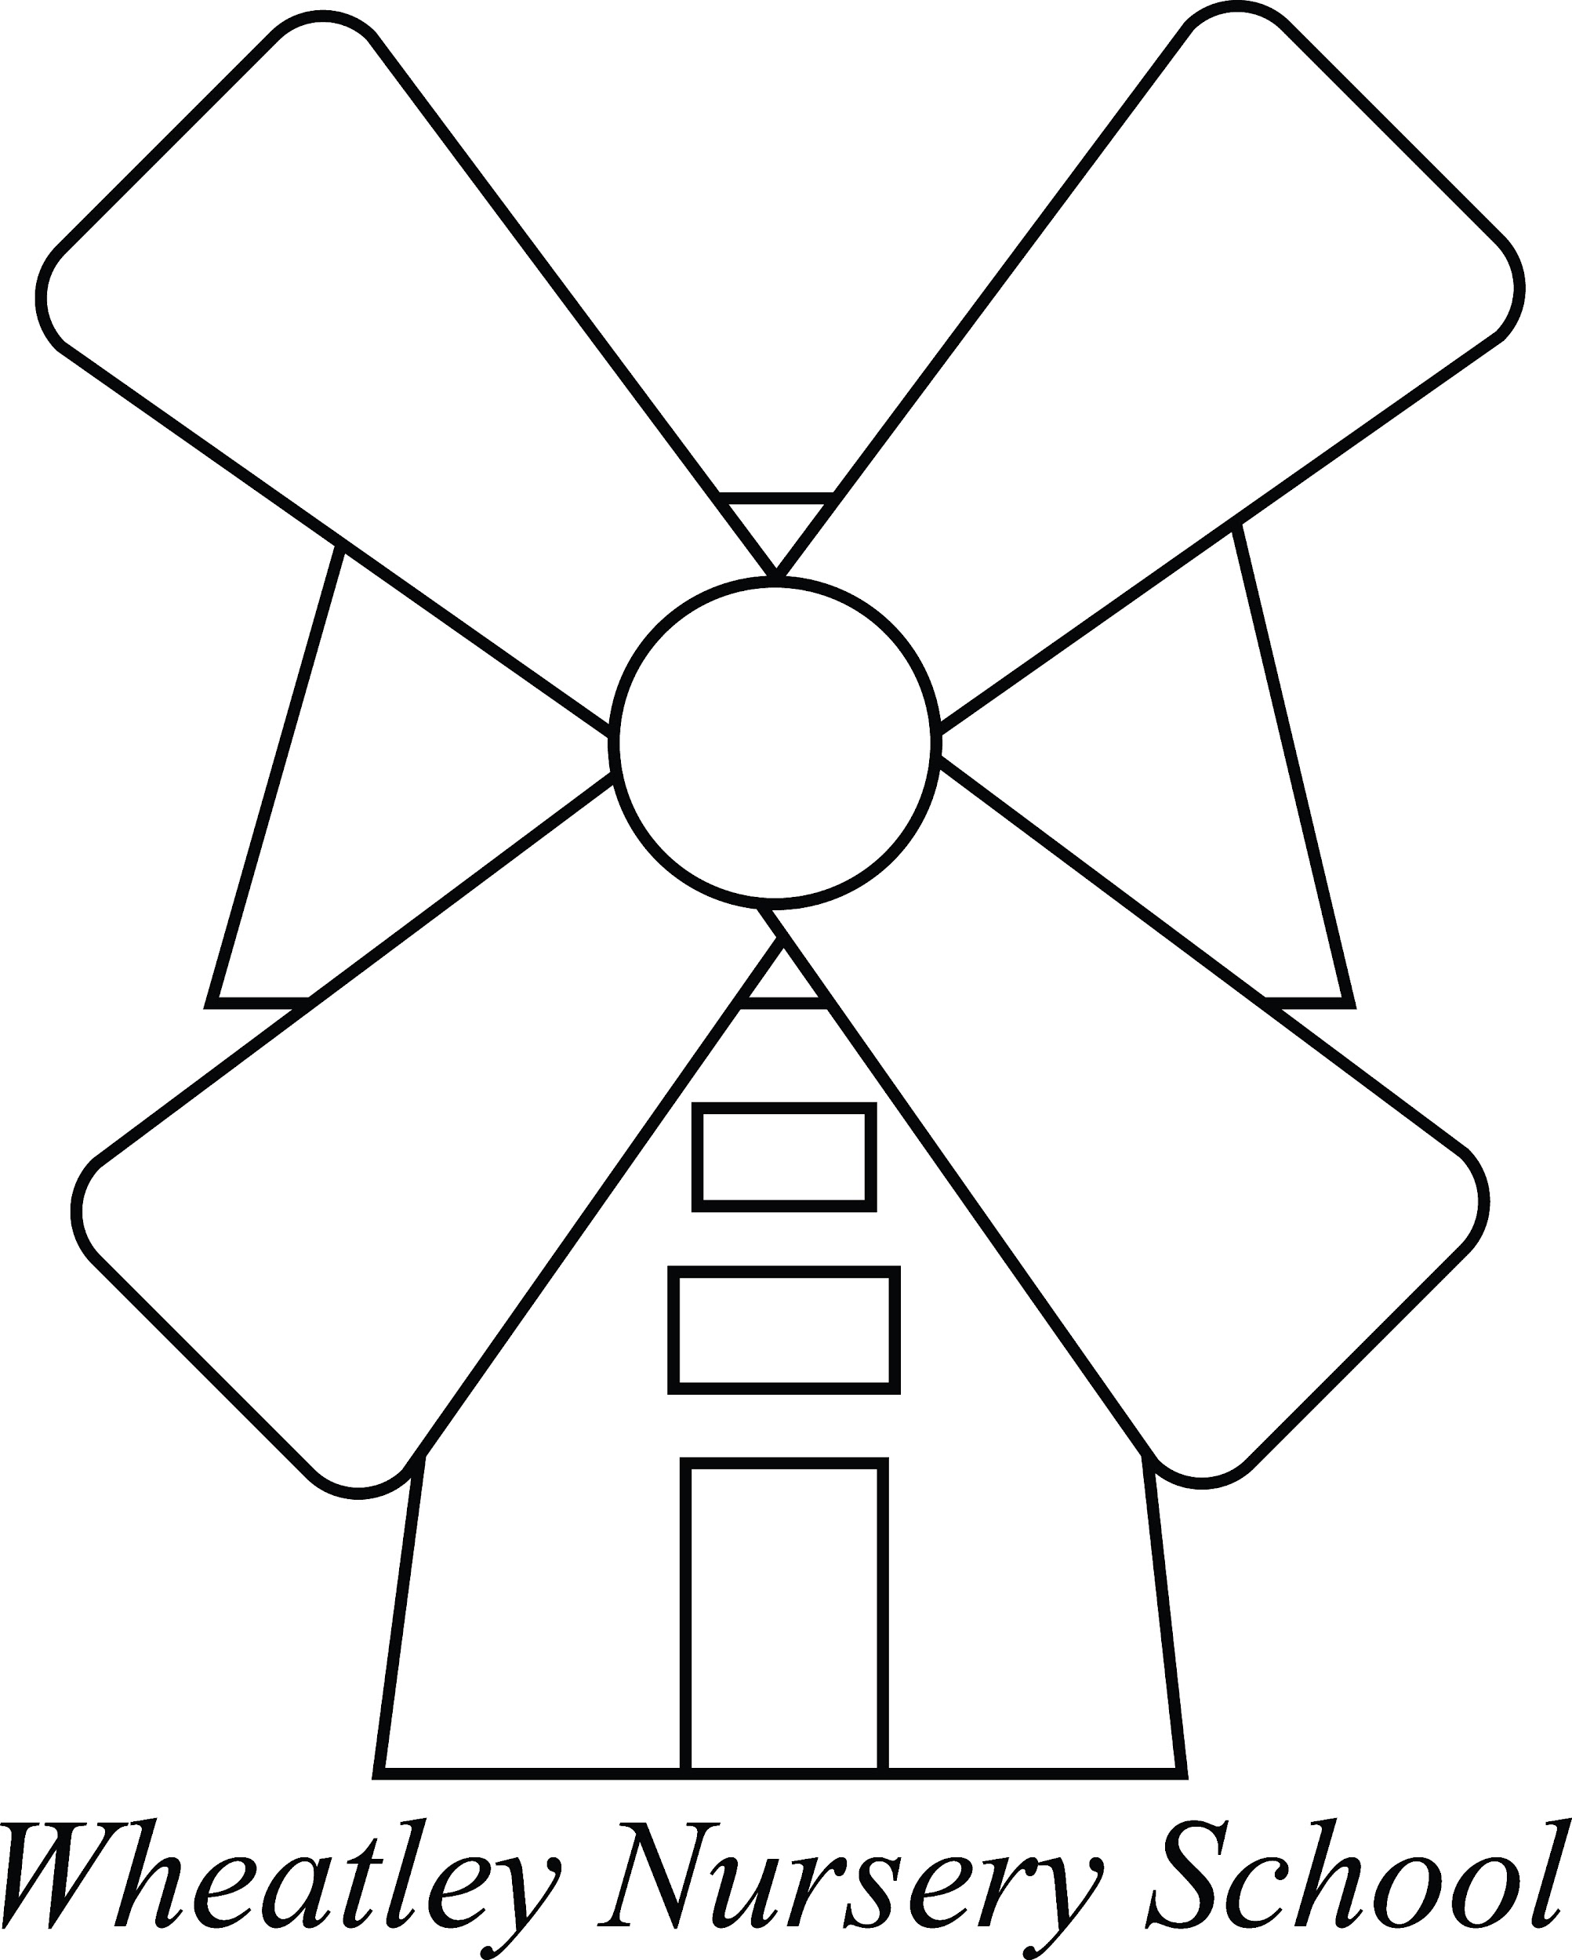Promoting Positive Behaviour
STARR (Setting Trigger Action Response Record) Observation Record

How to use the information gathered from the STARR Observations Record:

When - Day and Time
Does the unwanted behaviour happen at the same time each day? (Could the child/young person be hungry, thirsty, tired, bored?)
Does the unwanted behaviour happen on the same day each week?
Where did it happen?
Does the unwanted behaviour happen more often during structured activities, unstructured/free play or tidy-up time? Does it happen more indoors or outside?
Is it at noisy times or quiet times?
What provoked it; What happened before?
Is there an obvious trigger, or pattern emerging to show what made the child/young person behave in this way?
Is there a problem in sharing, change of activities, or understanding boundaries?
What did the child/young person do?
Is it always the same unwanted behaviour? (e.g. Hitting, pushing, biting, arguing)
What did you do?
How did staff respond?
How did you support the child/young person?
Did you support the child/young person away from the situation?
Did you distract the child/young person?
Did you ignore the child/young person?
Did you remove toys/equipment that caused the problem
Review and Reflection
Has a pattern emerged?
Select one behaviour to work on first - one that is easy to change or one that is causing most disruption and put in an intervention for that individual child/young person, e.g. a Social Story to be read daily and shared with parents/carers, providing increased sensory/movement breaks, or changing their position in class
Can the information be used to inform the EHCP outcome for SEMH?
Does the information need to be used in a referral to external agencies

