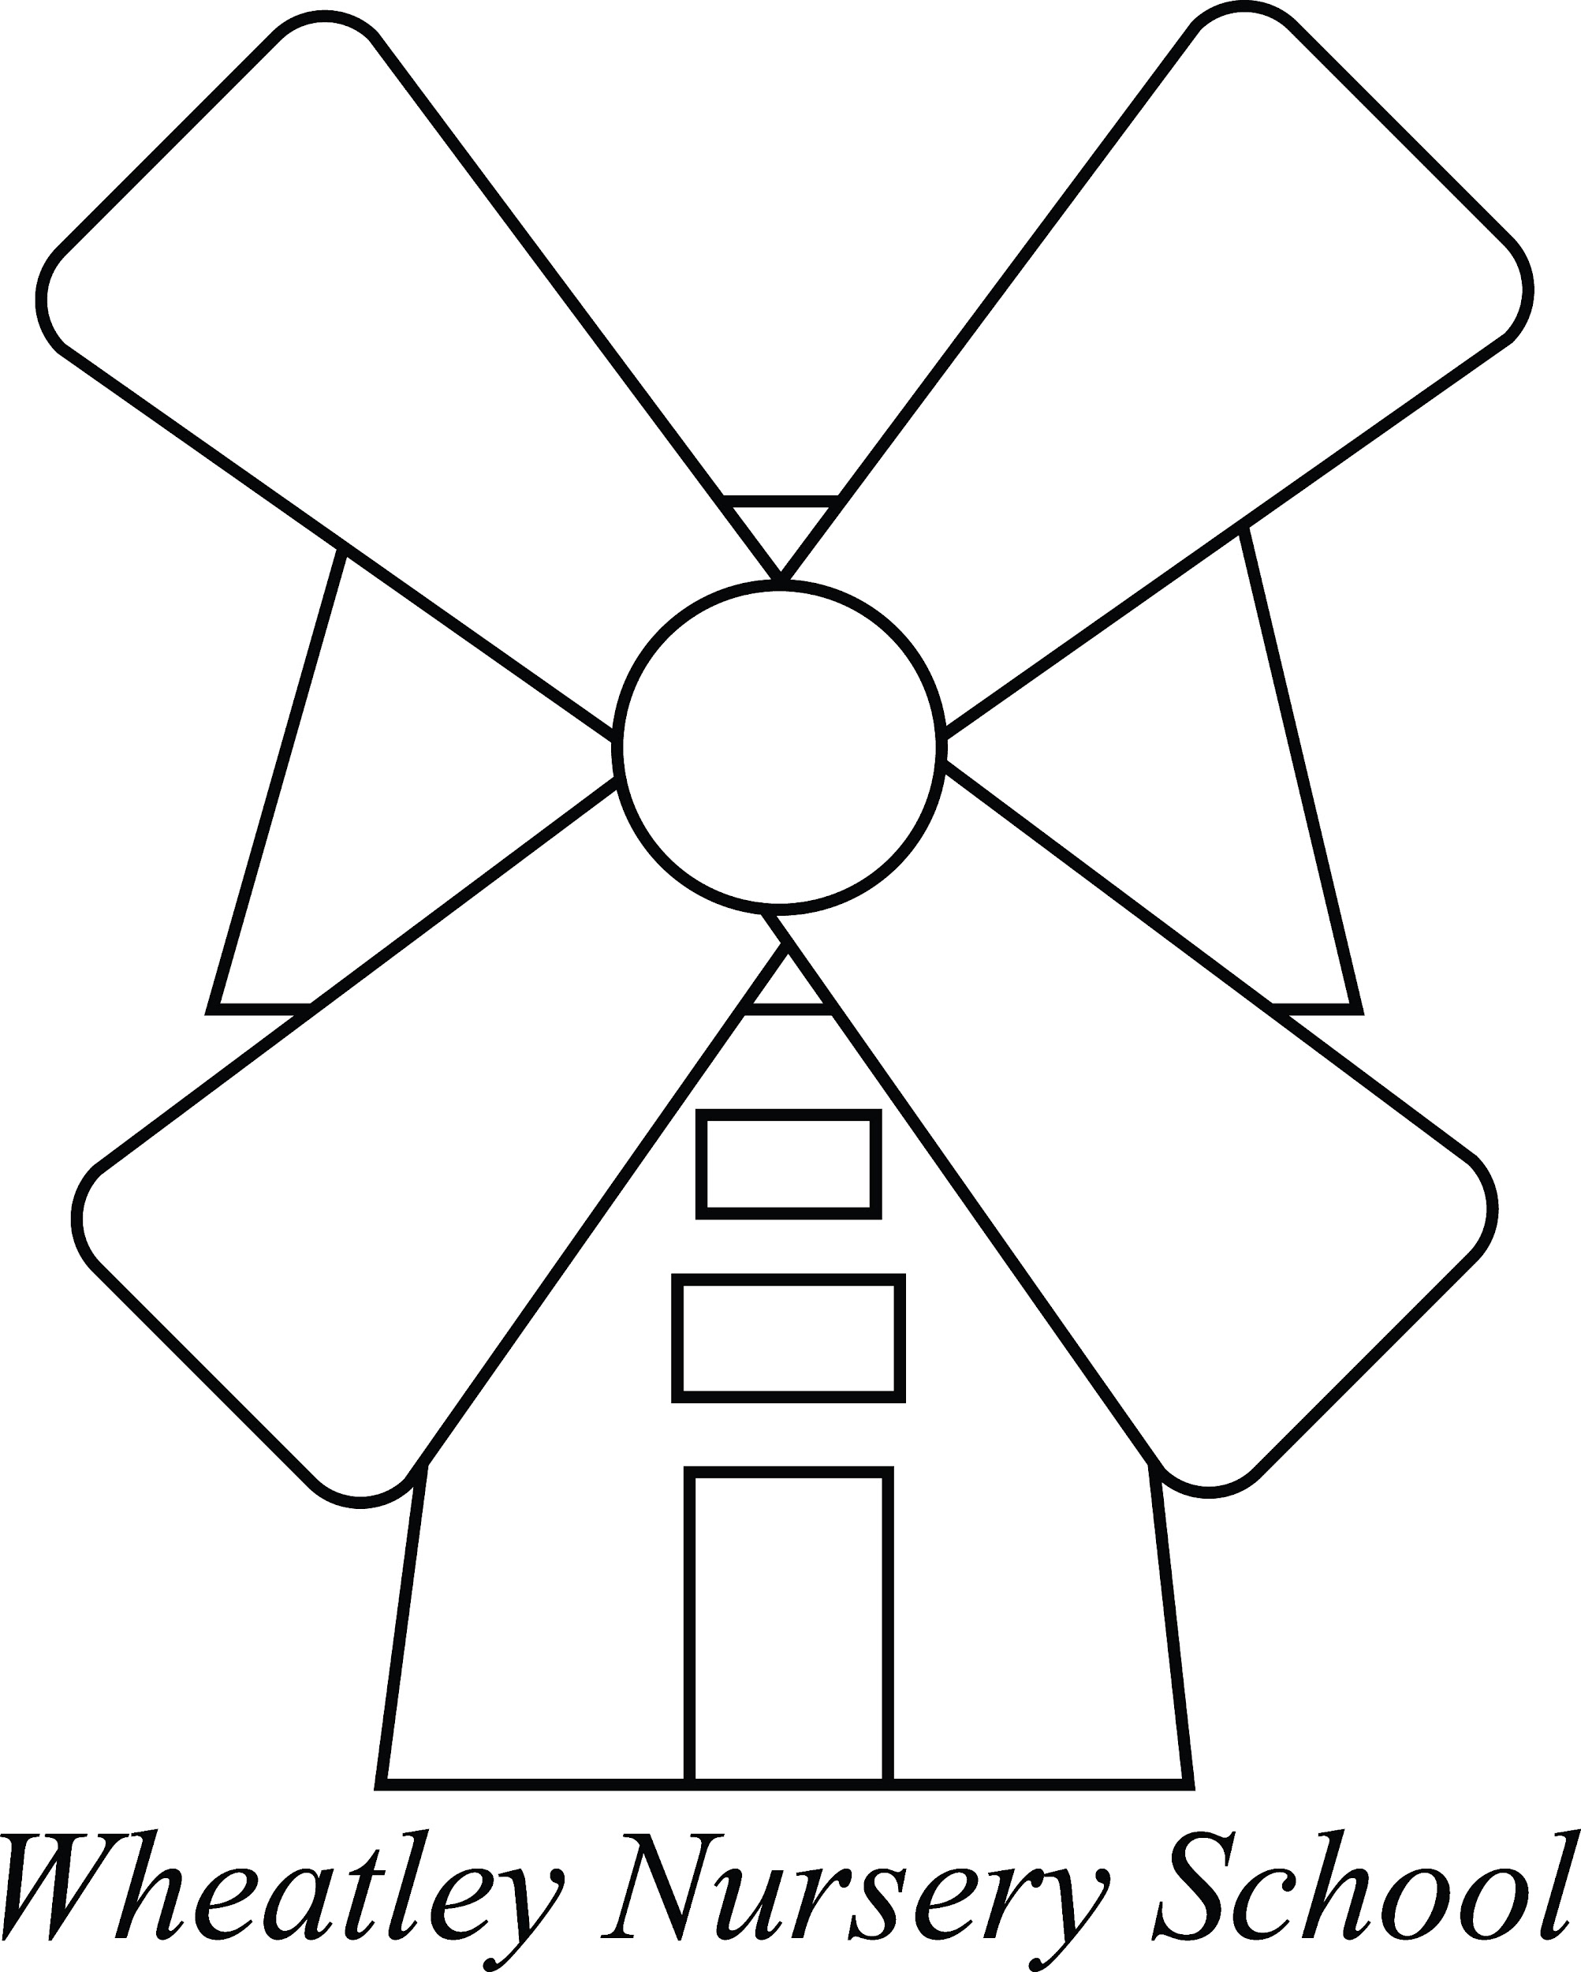

SEND Policy

The Federated Governing Body of John Watson and Wheatley Nursery Schools have adopted this policy.

Signed by Lynn Wong

Chair of Governors.

Date: April 2023
Review date: April 2024

This policy will be reviewed as per the review schedule set by the Governing body or in accordance with policy updates issued by Oxfordshire County Council (whichever is sooner).

Philosophy
We recognise the value of nursery education for all children and especially those with Special Educational Needs and Disabilities. We value parental contribution and involvement, visiting all our children prior to admission. This often helps us to identify a need, whether this has previously been identified or not. We strive to include all children in the life of our nursery, encouraging participation in all areas of the EYFS curriculum and in special events and activities.

Definition of Special Educational Needs and Disability (SEND)
A child has special educational needs if he or she has a learning difficulty or disability which calls for special educational provision to be made for him or her.
A child has a learning difficulty or disability if he or she:
- Has a significantly greater difficulty in learning than the majority of others of the same age or
- Has a disability that prevents or hinders him or her from accessing facilities of a kind generally provided for others of the same age in mainstream schools.

At Wheatley Nursery School we cater for children with a range of needs, which in the past have included
- Development delay
- Speech delay and disorders
- Autistic Spectrum disorders
- Hearing impairment
- Visual impairment
- Physical needs
- Social Emotional and Mental Health
- Genetic disorders
- Dietary needs
- Medical needs

Policy Objectives
- Recognise individual needs through gathering information from a range of sources from admission and throughout a child’s time at WNS
- Ensure all staff understand their responsibilities to children with SEND and have regard to the SEND Code of Practice 2014.
- All children with Special Educational Needs and Disabilities regardless of their need/s will be able to access the EYFS curriculum in all areas of our nursery at their own level and with the necessary support.
- Ensure that all staff and governors are up to date with safeguarding and SEND policies and training.

This means that…
- Early identification of individual needs is highlighted and actioned at the earliest opportunity.
- Actions are guided by a Graduated Individual Response approach
- Communication is open and effective with families (partnership with parents)
- Multi-agency working supports effective support in and out of school
- Home visits prior to admission gives parents the opportunity to discuss any problems they feel their children may have. These are especially beneficial in the case of children with already established special educational needs and disabilities
- All staff support all children and are aware of those children with specific difficulties or needs and how best to support them
- We give all our children the best start to Primary School, by providing transition activities prior to their moving on
- We are committed to accessing any SEND professional development to enhance our practices
- We seek additional help including applying for additional support funding, or an EHCneeds assessments
- We identify children who may be gifted and talented and make reasonable adjustments for their needs

Roles and Responsibilities
- Our Governor with designated responsibility for SEND is James Keeley
- The SENCo is Natalie Wilson
- The SENCo writes and reviews a SEND Information Report. This is displayed on our website.

Wheatley Nursery School regularly reviews the progress of all children and where progress is slow the first response is high-quality targeted teaching which may be in small groups or through short, individual interactions between staff and children.

We recognise that slow progress does not necessarily mean a child has special educational needs. In deciding whether to make special educational provision all the information available, including that from the child and parents, is gathered and viewed alongside national expectations of progress.

Where there is a need for more specialist expertise to identify the child’s needs and to determine the most effective approach, services such as educational psychology, specialist teachers or health may be approached. Parents will be informed and invited to contribute at every step.

Role of our SENCO:-
- The SENCO has responsibility for the day-to-day implementation of the SEND Policy and for coordinating provision for children with SEND including making referrals to other services and making initial and summative assessments

- The SENCO will work with staff, parents and other agencies to consider the best ways to support a child in our school so that they make appropriate progress in their learning

- The SENCo will keep a Graduated Response record listing those children who may need additional support and this details the specific nature of that support

- The SENCO will advise will advise other staff regarding possible strategies to support a child

- The SENCO will collect, record and update information about individual children with Special Education Needs and Disabilities

- The SENCo will liaise with the teacher in school regarding interventions, their outcomes and next steps

- The SENCO will chair EHCP meetings

How do we identify and give extra help to children and young people with SEND?
The school uses Oxfordshire County Council’s guidance ‘Identifying and supporting Special Educational Needs in Oxfordshire schools and settings’.
The guidance sets out:
- How we identify if a child has a special educational need
- How we assess children and plan for their special educational needs, and how we adapt our teaching
- Ways in which we can adapt our school environment to meet each child’s needs
- How we review progress and agree on outcomes and involve you and your child in this

Click here to read it:
https://www.oxfordshire.gov.uk/cms/sites/default/files/folders/documents/childreneducationandfamilies/educationandlearning/specialeducationalneeds/SEND/CompilationFoundationYearsandPrimary.pdf

Organisation of Special Needs and Disabilities Provision and Admission
All children are visited prior to admission.

All children are allocated a Key Person responsible for their record keeping and development during group time.

Staff liaise with the SENCO for support when necessary.

Each member of staff keeps a Learning Journey for each of their key children.

SEND pupils are discussed at weekly staff meetings and regular Student Review Meetings between the SENCO/Headteacher and the nursery teacher;
Whole group pupil progress data is also collated and analysed at least termly to ensure our children with SEND make progress appropriate to their individual needs.

Graduated response to SEND
SEND support is based on a cycle of action that can be revisited with increasing detail, increasing frequency, and increased involvement of parents.
The cycle of action has four stages: assessing; planning; doing and reviewing the provision, as outlined in the SEND Code of Practice, 2014.

We always discuss any initial concerns with parents. We share ideas, asking parents to contribute. If appropriate we complete a SEND Outcomes plan. We inform parents of all developments regarding their child and they will be invited to attend all reviews and give their input. Parents/carers are given a copy of the plan and review outcomes.

A Team Around The Family assessment may be completed, when it is felt that the child/and or family needs some support from school and other agencies.

Mid and end-of-year review meetings are also held, where decisions are taken as to whether the child will need an Education and Health Care Plan (EHCP). If a panel decides that an EHCP would be beneficial to the child and is appropriate, then an ‘All About Me’ meeting would then be arranged by the SENCo to bring together relevant people, including, most importantly, parents.

SENCOs from receiving Primary Schools will also be invited to attend review meetings or TAF meetings as well as visit the child in Nursery.

Pupil Voice
Children communicate these to us as part of the person-centered approach using methods appropriate to a child's preferred communication such as photos or symbols.

Links with other agencies
Wheatley Nursery School is able to call upon the expertise of a range of support services. This takes place following discussion between parents, the key person, and Co-Deputy Head Teacher/SENCo. To request assessment and advice a Single Point of Request for Involvement (SPORFI) form is completed and requires parental consent.

We have access to a range of specialist support services including:

- Educational Psychology
- Health Visitors and Pediatricians.
- Primary Child and Adolescent Mental Health Services (PCAMHS)
- Oxfordshire School Inclusion Team
- Therapy services, e.g. physiotherapy, Speech and Language Therapy
- Early Years Advisory Teachers

Information about these services and what they offer can be found on the Oxfordshire County Council SEN web pages: https://www.oxfordshire.gov.uk/cms/public-site/special-educational-needs-and-disability-send

Partnerships with Parents
- A close relationship with parents is essential in the education of young children. We give this relationship a firm foundation with our home visit, prior to entry, where we gain any information parents/carers can give us about their child
- We encourage parents to talk to us about any concerns at any time, but also hold regular Parent Meetings.

Physical Access
- We have wheelchair access to all areas of the Nursery and hoists
- Our school is on 1 level, with no stairs to negotiate
- We have a specially designed shower room with a changing bed
- We have a disabled toilet
- All children can access our EYFS curriculum
- We have disabled parking spaces
- Appropriate provisions are made when necessary for children being admitted to school

Inclusion
Wheatley Nursery School is an Inclusive School, engendering a sense of community and belonging through our:

- Inclusive ethos
- Broad and balanced curriculum for all children
- Signing and Symbols
- Systems for early identification of barriers to learning and participation
- High expectations and suitable targets for all children
- Welcome for all pupils

Evaluating the success of the Policy
- Monitoring by the Headteacher
- Monitoring by the SENCO
- Approved by the Governing Body
- Childrens’ progress data
- Review meetings which will monitor the child and school performance

This Policy should be read in conjunction with the following policies:
- Safeguarding
- Equalities Objectives
- Supporting Children with Medical conditions
- Gifted and Talented Policy

